**Project Planning Phase**

**Project Planning Template (Product Backlog, Sprint Planning, Stories, Story points)**

|  |  |
| --- | --- |
| Date | 18 October 2022 |
| Team ID | PNT2022TMID07719 |
| Project Name | A Novel Method for Handwritten Digit Recognition System |
| Maximum Marks | 8 Marks |

**Product Backlog, Sprint Schedule, and Estimation (4 Marks)**

Use the below template to create product backlog and sprint schedule

| **Sprint** | **Functional Requirement (Epic)** | **User Story Number** | **User Story / Task** | **Story Points** | **Priority** | **Team Members** |
| --- | --- | --- | --- | --- | --- | --- |
| Sprint-1 | Registration | USN-1 | As a user, I can register for the application by entering my email, password, and confirming my password. | 12 | Medium | Ramalingam V  Narayanan MS |
| Sprint-1 | Login | USN-2 | As a user, I can log into the application by  entering email & password. | 8 | Medium | Ramalingam V  Narayanan MS |
| Sprint-2 | Dataset Collection and Pre-Processing | USN-7 | To train the model, the dataset is collected and pre-processed. | 10 | High | Akash Iyer  Tharun Kumar, Narayanan MS |
| Sprint-2 | Training & saving the model | USN-7 | With the help of the pre-processed data the model is trained and the model is tunned for producing higher accuracy. | 10 | High | Akash Iyer  Tharun Kumar |
| Sprint-3 | Integrating the model with Flask API | USN-8 | The image given by the user is processed and given to the model for prediction and the results are sent back to the user. | 14 | Medium | Ramalingam V  Akash Iyer |
| Sprint-3 | Creating the database. | USN-8 | The database is used to store the user details and the previously processed cheques | 6 | Medium | Tharun Kumar |
| Sprint-4 | Image scanning and uploading | USN-3,4 | The user uploads the image of the cheque to be processed either by scanning or uploading it from the local file structure. | 12 | Medium | Narayanan MS  Ramalingam V |
| Sprint-4 | Displaying the results | USN-5,6 | We get the results from the backend and display it to the user. | 8 | Low | Akash Iyer  Tharun Kumar |

**Project Tracker, Velocity & Burndown Chart: (4 Marks)**

| **Sprint** | **Total Story Points** | **Duration** | **Sprint Start Date** | **Sprint End Date (Planned)** | **Story Points Completed (as on Planned End Date)** | **Sprint Release Date (Actual)** |
| --- | --- | --- | --- | --- | --- | --- |
| Sprint-1 | 20 | 6 Days | 24 Oct 2022 | 29 Oct 2022 | 20 | 29 Oct 2022 |
| Sprint-2 | 20 | 6 Days | 31 Oct 2022 | 05 Nov 2022 | 20 | 05 Nov 2022 |
| Sprint-3 | 20 | 6 Days | 07 Nov 2022 | 12 Nov 2022 | 20 | 12 Nov 2022 |
| Sprint-4 | 20 | 6 Days | 14 Nov 2022 | 19 Nov 2022 | 20 | 19 Nov 2022 |

**Velocity:**



$\frac{20}{6}$ = *3.33*

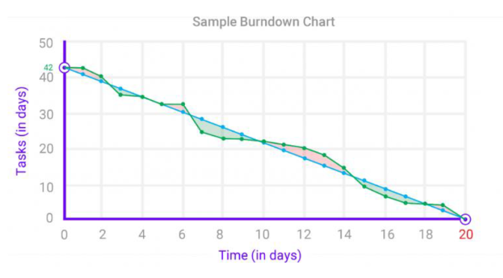**Burndown Chart:**